

**School of Electrical and Electronics Engineering**

**Coursework Title: A Software Solution Based on Specifications**

**Module Name: Advanced Programming**

**Module Code: 7301SDM**

**Lecturers: Dr Brahim Benbakthi**

**Hand-in Date: 15/12/2019**

**Programmes: MSc Sensors, Data and management**

**Name: Monisha Yuvaraj**

**Student ID: 891667**

|  |  |
| --- | --- |
| **Table of Contents** | **Page No** |
| 1. **Introduction** | **3** |
| 1. **Coursework Specification** | **3** |
| 1. **Answers** | **3** |
| 1. **Results** | **7** |

**ADVANCE PROGRAMING SOFTWARE DOCUMENTATION**

1. **INTRODUCTION:**

C # (C sharp) is simple and powerful object-oriented language developed by Microsoft, since 2002 C sharp is evolving. C sharp is an advance programming language runs on .Net platform or developer to create or establish most innovative cloud with short learning curves. C# is a general-purpose, multi-paradigm programming language encompassing strong multi tasking ability. It is most commonly used for window application, web/website application and development.

1. **COURSEWORK SPECIFICATION:**

Using C sharp create a window application which is used access number of student records that are held in a text file, where one student record occupies one line of text. Each record consists of five fields or items of data, which are separated by commas. The fields are Family name, First name, Second name, Date of enrolment and finally Gender.

1. **ANSWERS OR USERGUIDE OF THE APPLICATION DEVELOPED:**

(1) Create a Text file for 10 students with the record of family name, first name, second name, date of enrolment and finally gender.

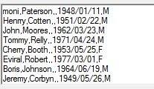

(2) C# Windows application to read first, last, previous, and next. When X is pressed application must get terminated, this process is called termination process.

Windows form1 panel as follows.

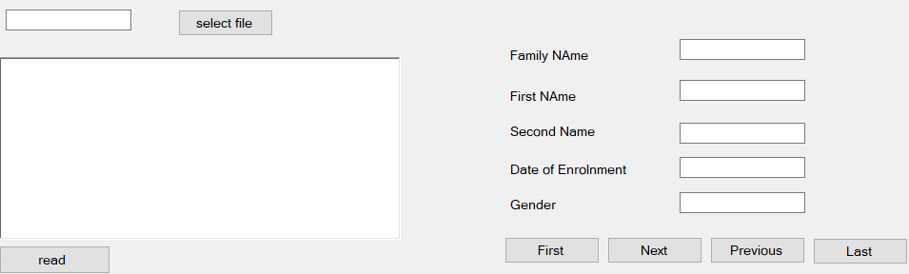

Where after execution, when we get form 1panel, if you press the X key the whole application gets terminated, this is the use of the function, where the user can quickly terminate in any case of emergency or smart way. The Functions of following buttons:

1. **SELECT FILE BUTTON:** Select file button is used for reading the text file path and to get the data. The coding states that the read file path and write file path to the left text box.
2. **READ BUTTON:** Read button is used to read text file. from select file button from that and which is able to show the 10 names in text box. This coding states that to read the text file and write into text box and made an array to set the data in five fields using **‘\n’** to separate names of text file.

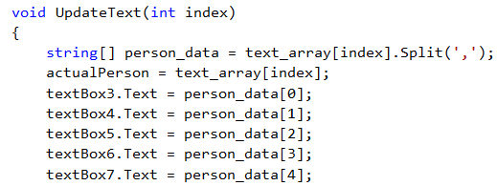

The above coding is with 5 different text boxes as shown with family name, first name, second name, date of enrolment and gender, where the five field of the person is distinguished.

* **FIRST BUTTON:** It is used to display details of first person in 5 fields of data.

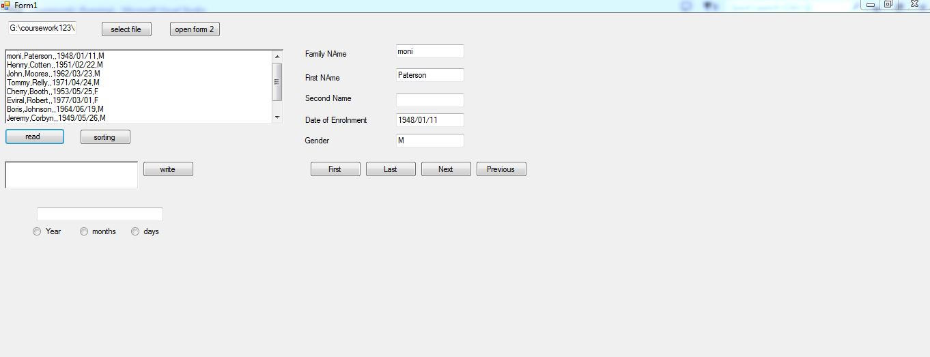

In this program we have all the given information. Code used;

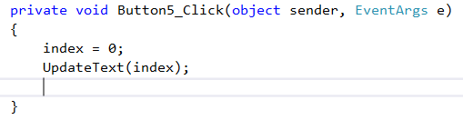

Code states that when First button is pressed, only first line of text should be read. Index = 0 means 1st persons detail.

* **LAST BUTTON:** Last button is used to select last name of the person, with complete five fields of data.

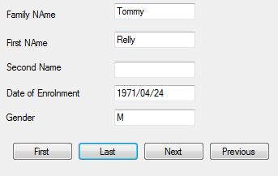

Codes;

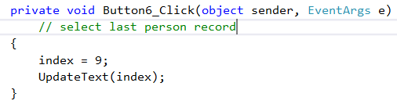

For getting last persons information, we need to press LAST which means index=9, since range of the index is from 0 to 9 only, if the number exceed more than 10 it shows error. The index 0-9 is a set of records of 10 students with complete 5 fields of data.

* **NEXT BUTTON:** It is used to select details of next person using **increment** (index++) in the coding which means when we have details of first person in the form 1, when we press next it gets incremented and goes to or get forwarded to second persons details.

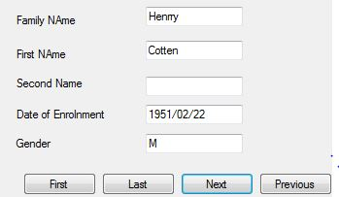

Coding

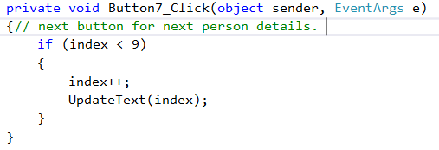

* **PREVIOUS BUTTON:** it is used to select details of pervious person using **decrement (**index--) in the coding which means, when we have details of 10th person in the form 1, when we press previous it gets decremented and comes down the line like with 9th person details.

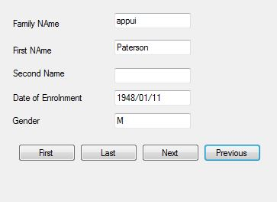

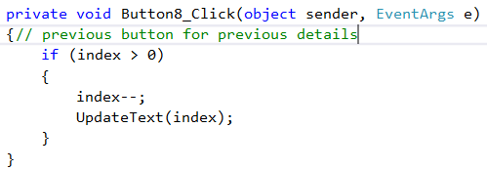

**TERMINATION USING X KEYBOARD:** the code which is used to terminate the application by simply pressing the key.

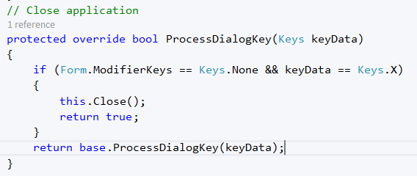

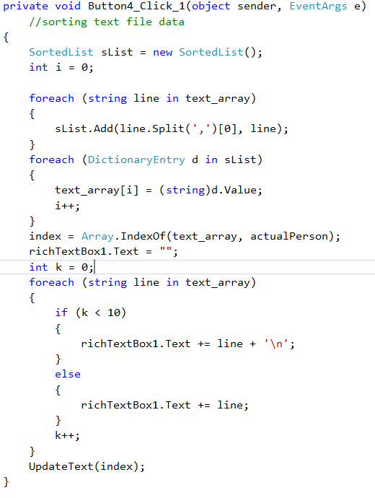**(3) SORT BUTTON:** It is used to Sort text data into alphabetical order and write it into same text box. The coding is given below.

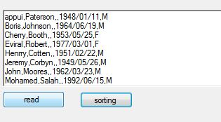

**(4) RADIO BUTTONS TO DISPLAY DAY, MONTH AND YEAR FOR PERSON:** In this part we can details on how long student is enrolled in college or any other institution with difference in the time of period of enrolment to current status.

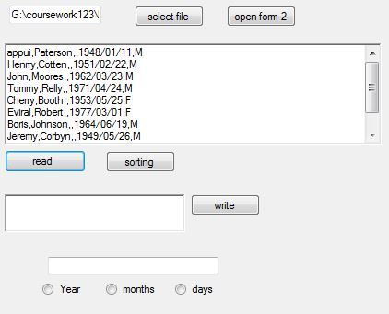

Coding

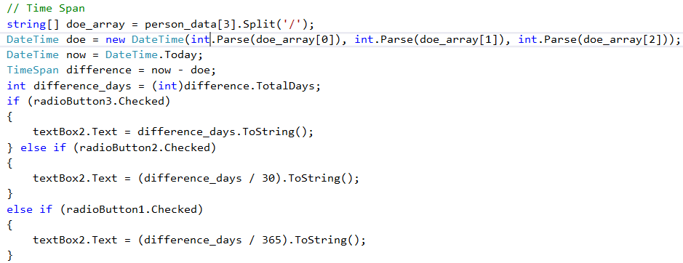

The above coding is stated to calculate difference in date, months and year in very simple way. First, calculated days then divide by 30 to get months and divide days by 365 to get data for year. Therefore, I calculated the difference between data for each student.

**(5) PROCESS OF MODIFYING DATA IN 2ND FORM OF WINDOW**

**Open form 2 button**

Form 2 button is used like in the case of any replacement or correction or any modification in names or text file can be done using this button. The form 2 button is derived using this method. (window application using C sharp in course model PPT).

The following code is used to open the 2nd form.

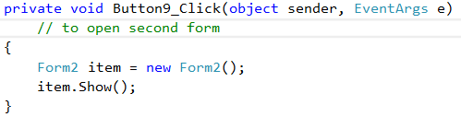

**Form 2**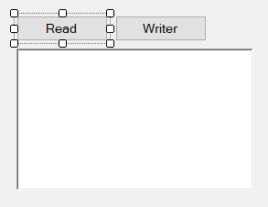

The code used for read and write in form 2;

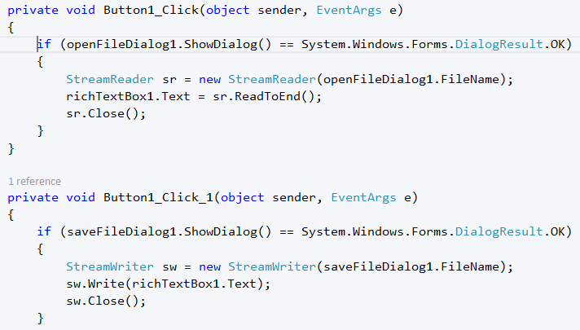

Stream reader is used to read the file path and stream write function is to write the text file and save it into text file, Once data is modified in the system it asks to save it once we done that part then it writes and save our data. Then it again allows to read the modified data.

**FULL PANEL WORKING DISPLAY:**



Once I run the simulation it starts reading the files form1 and form 2 immediately, where we need to be modify. By seeing first line name changes you can observe the changes. Then I pressed button Write to modify.

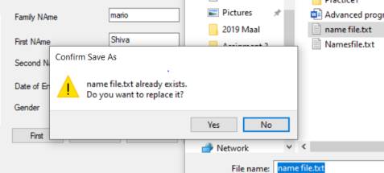

Once everything is fine and click yes file will replace with new name.

**MODIFIED NAME:**

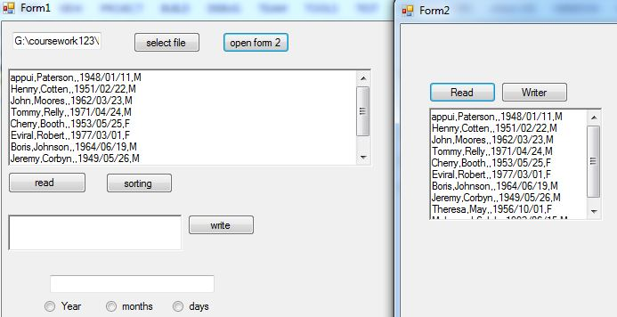

Now file is modified to new name. With this we can conclude the above file is working.

**TROUBLESHOOTING:**

1. This program only reads the TXT file, hence it does not read any other file.
2. The designed program have data entry limit upto 10 records only, if we entry anything more than 10 the program stops running.
3. The designed program is read line by line and it does not read line after we have blank space.
4. The designed program is modified to make sure that after every data entry we have used ‘,’ in the text file. Else the program may crash.
5. Once the program have any error it will automatically indicate to the line of code and program stops running.
6. To make any modification in files , we must select read button first to make changes and then editing then save it using form2. Using form 1 we must able to read the data again then it will show the modification that we done.
7. If so any blank in the text file, the program will show error and stop running.
8. **RESULT:**

The given coursework problem is solved with C sharp in window application.